**Efolio Week7 & Week8**

Name: Zehui Zhang

ID: 34103600

**Efolio Task 7.1**

**Screenshot set 1:**

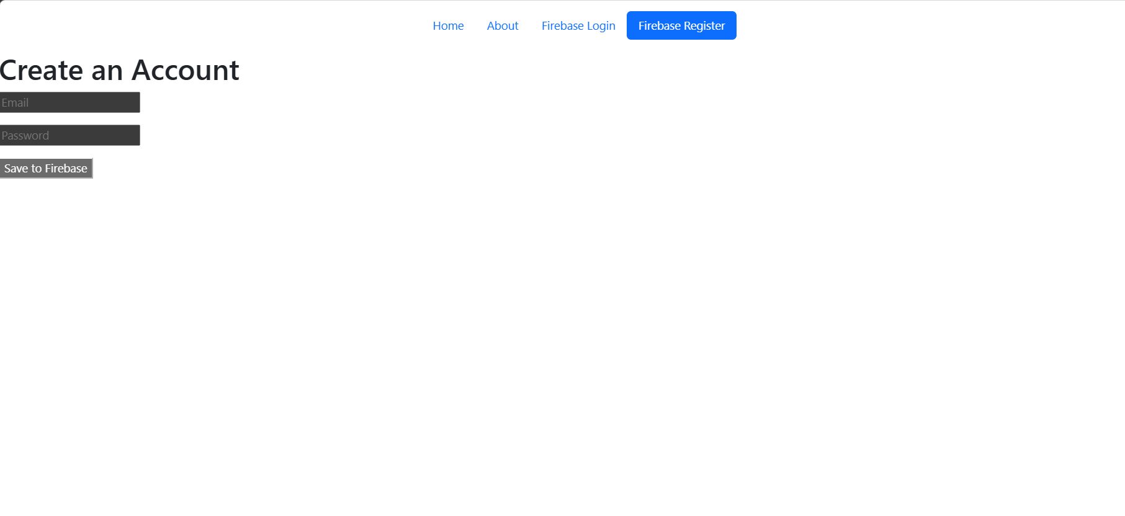

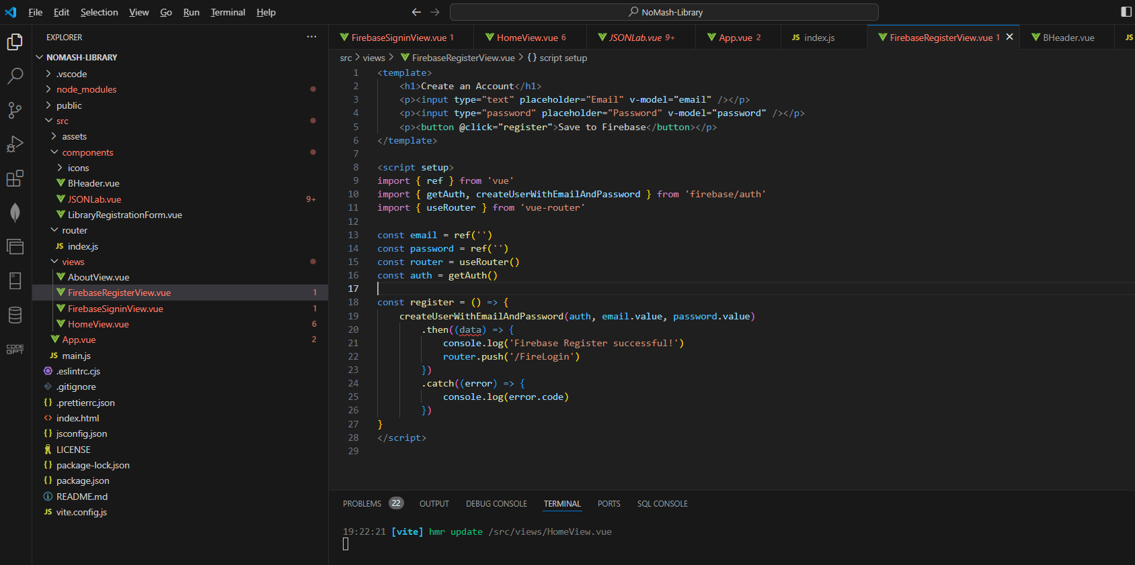

**Screenshot set 2**:

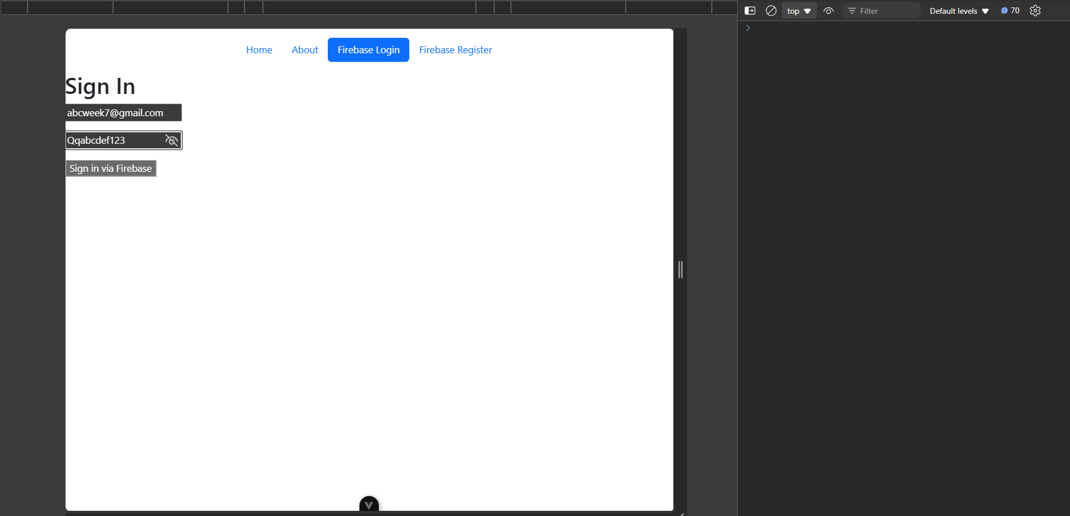



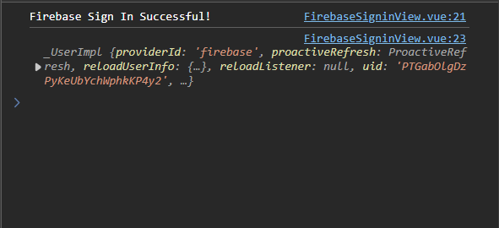

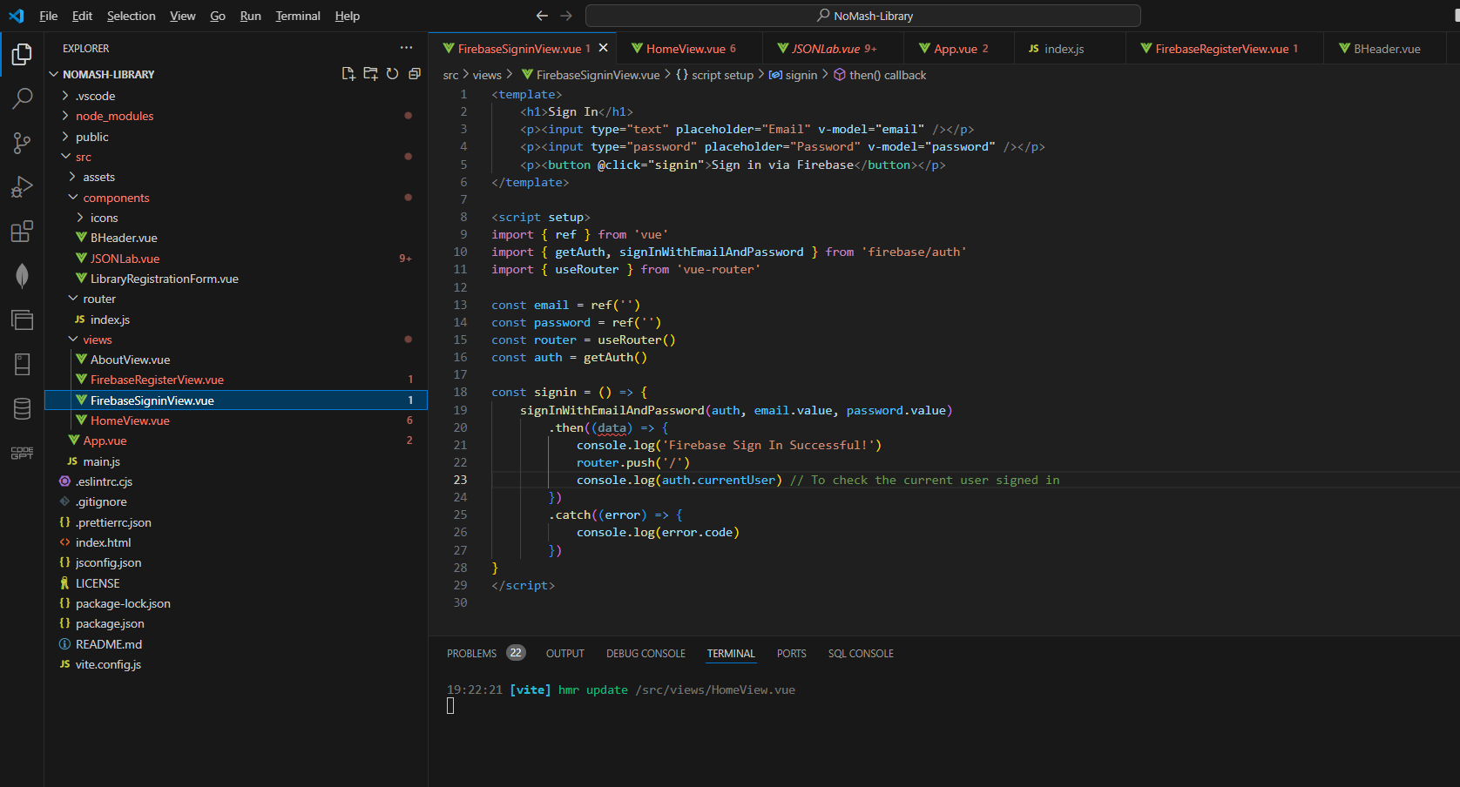

**Screenshot 3**:

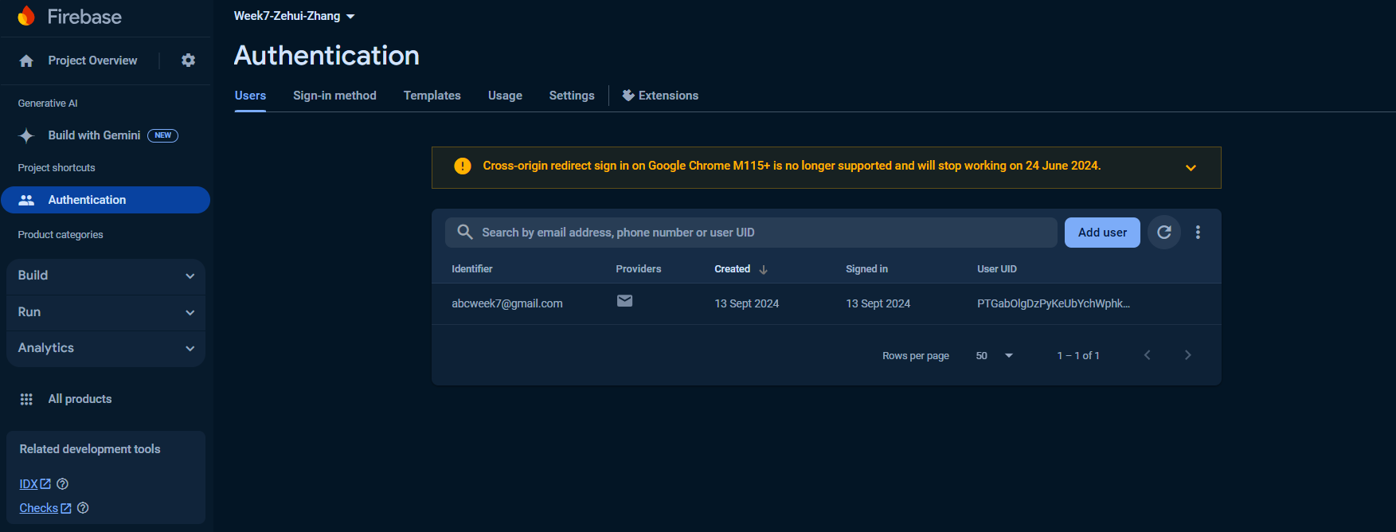

**EFOLIO TASK 7.2**

**Screenshot set 1:**

Sign-in with Admin account:

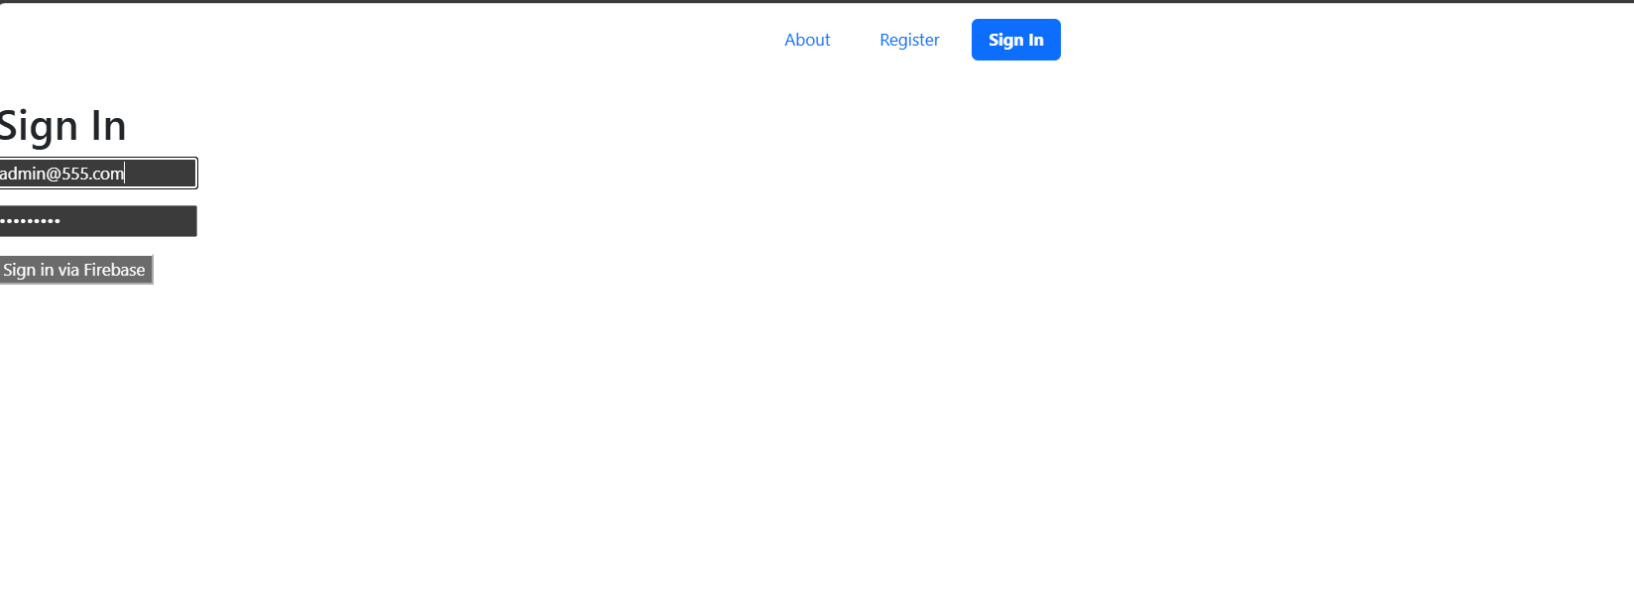

After the administrator logs in, they can see this page, which includes the admin dashboard:

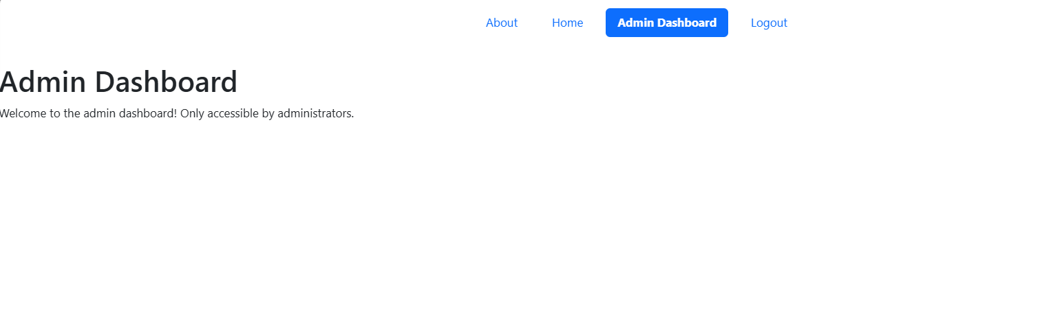

Sign-in with User account:

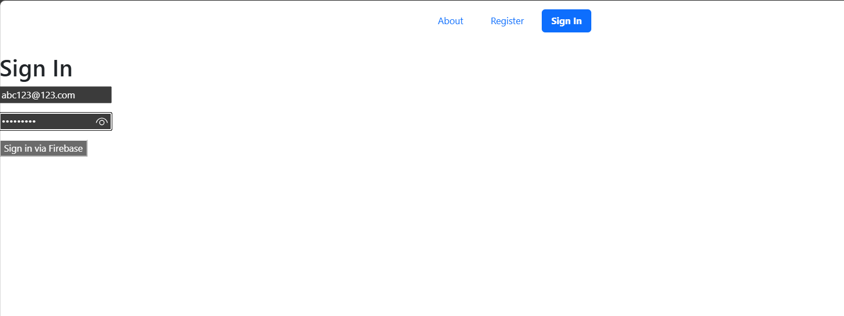

This is the regular user interface. We can see that the regular user interface does not include the admin dashboard, which demonstrates the functionality of multiple roles:

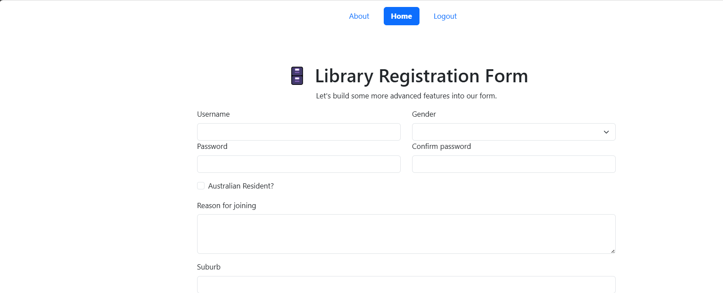

**Code:**

FirebaseSigninView.vue

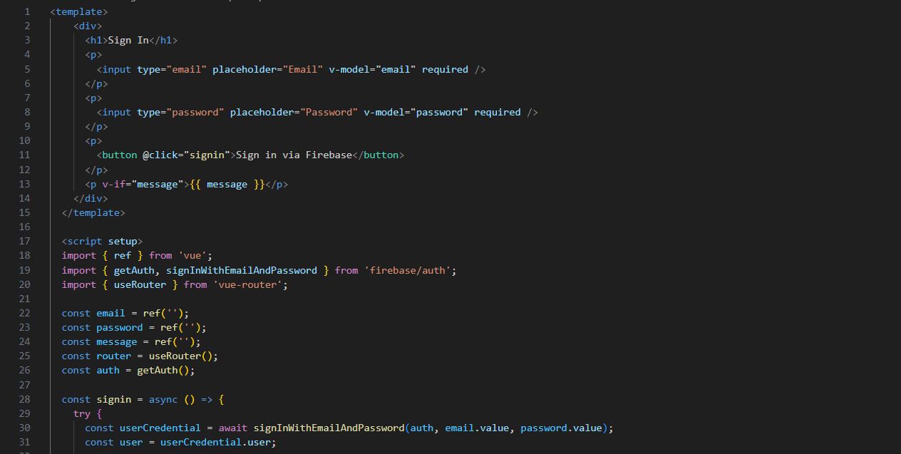

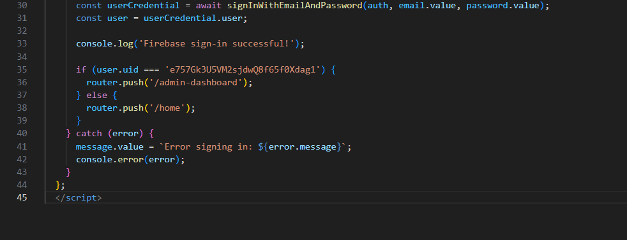

Index.js:

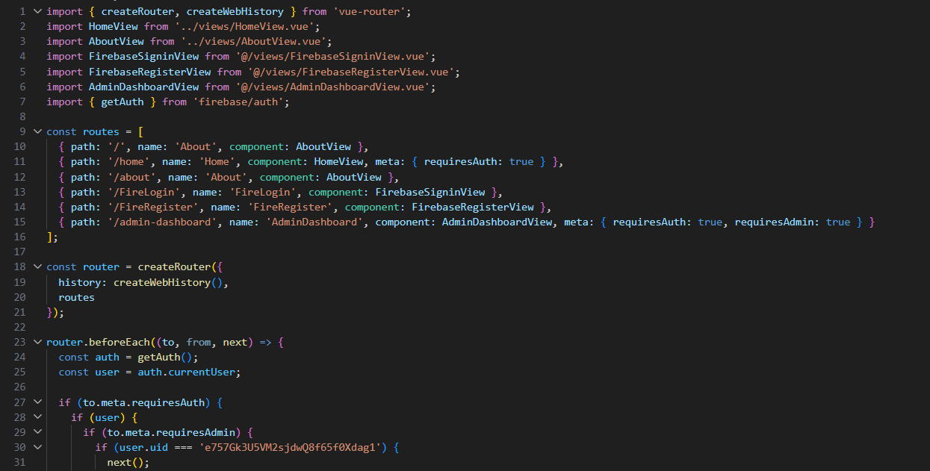

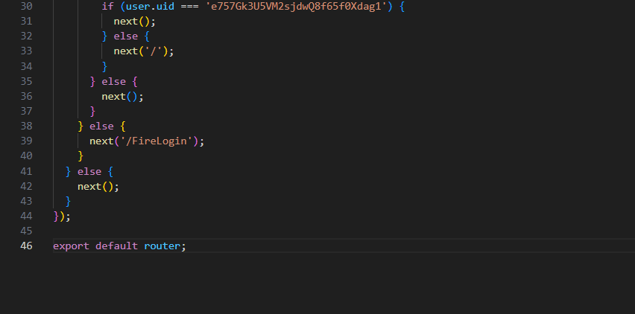

Bheader.vue:

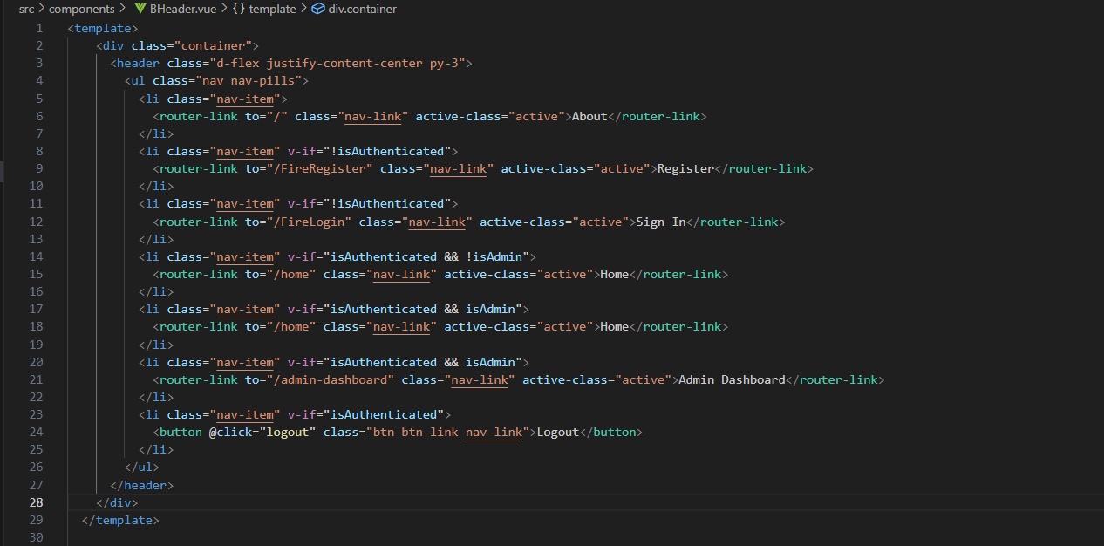

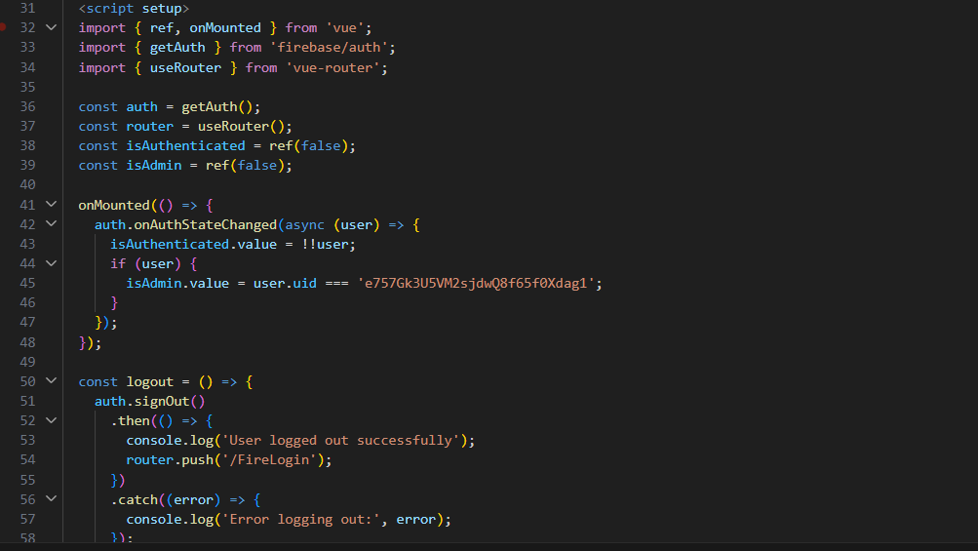

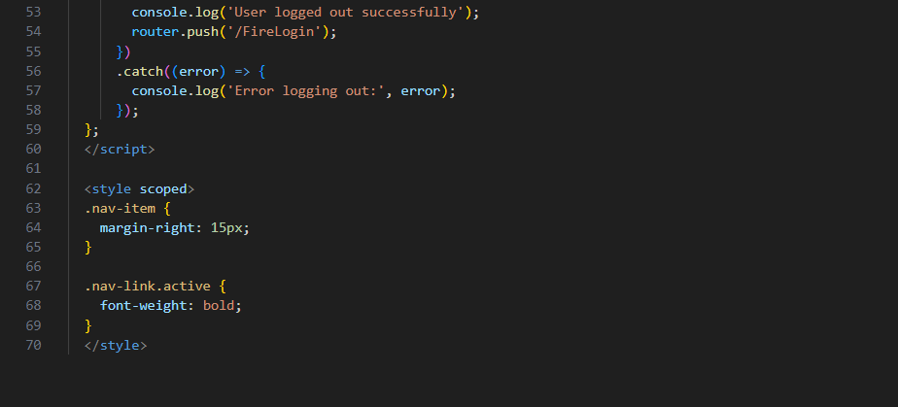

**Screenshot set 2:**

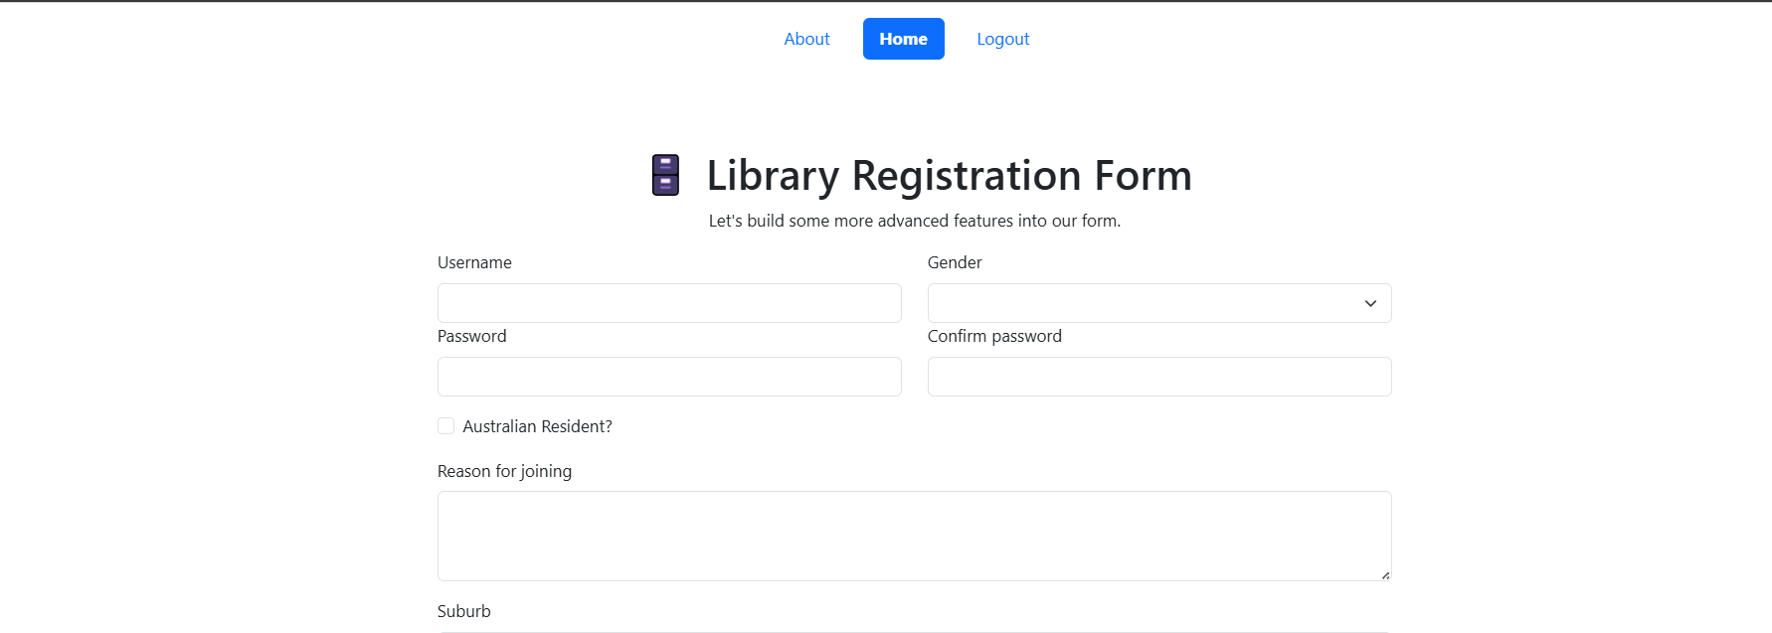

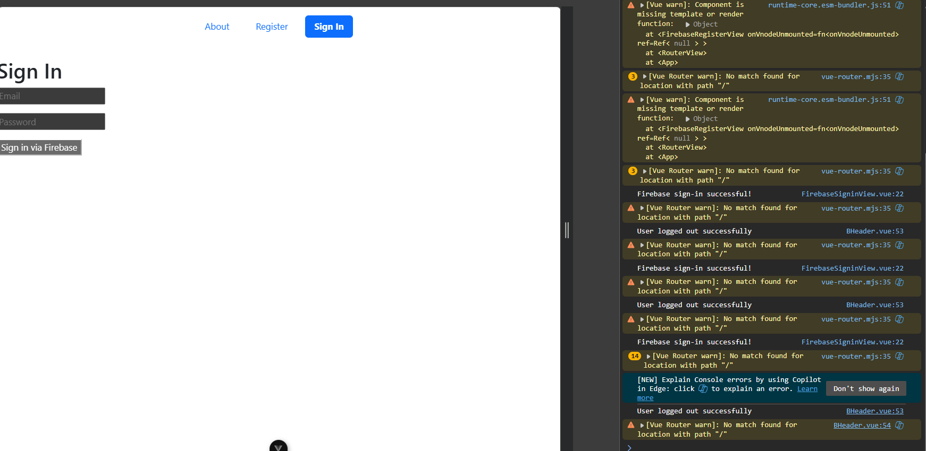

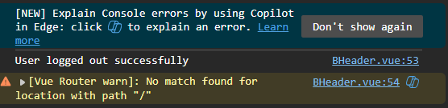

**Efolio Task 8.1**

**Screenshot set 1:**

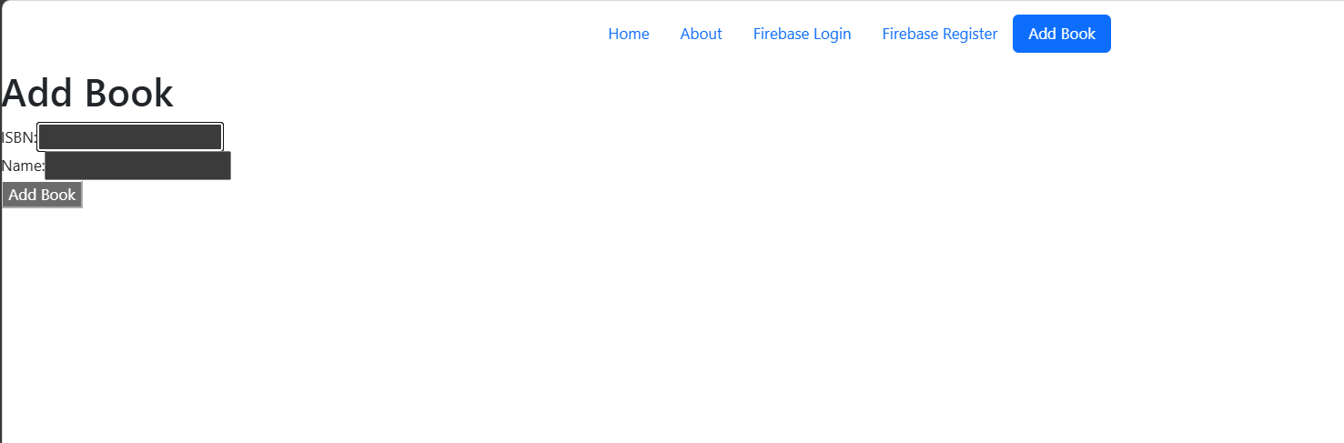

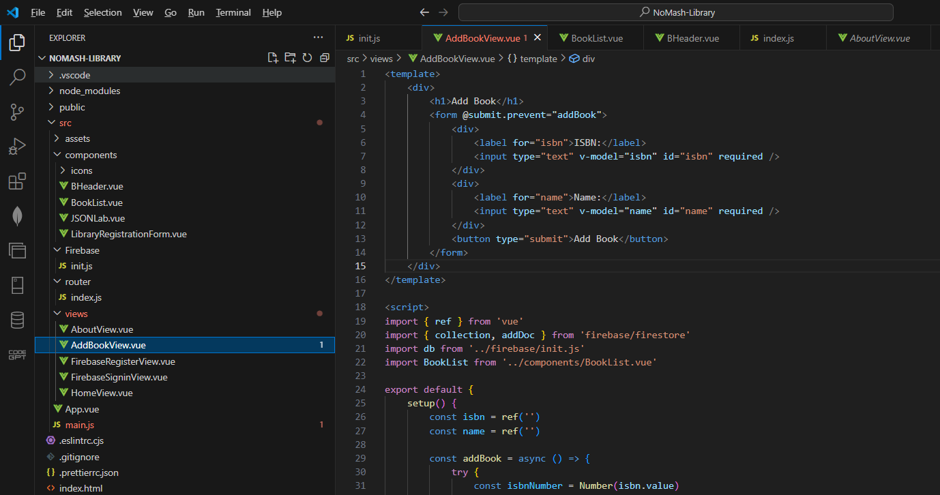

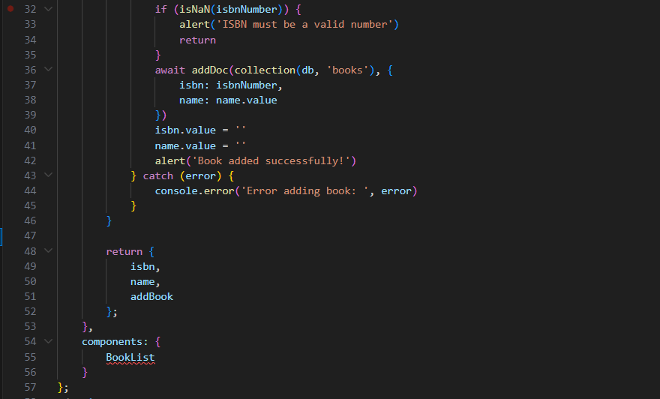



**Screenshot set 2:**

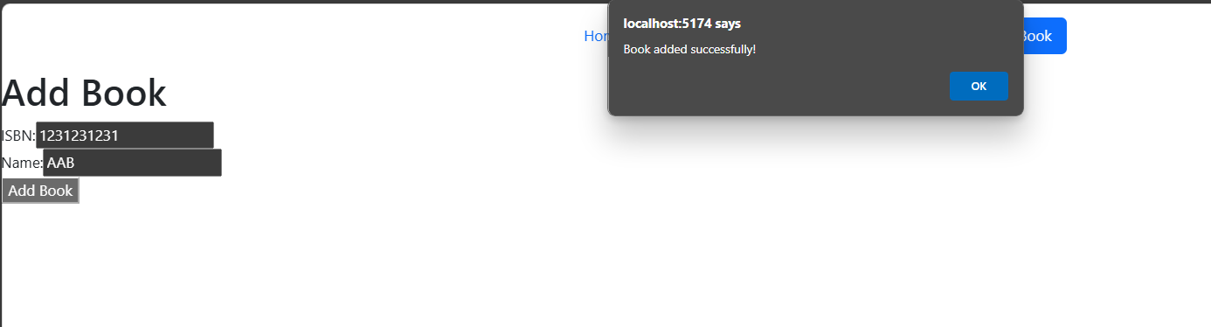

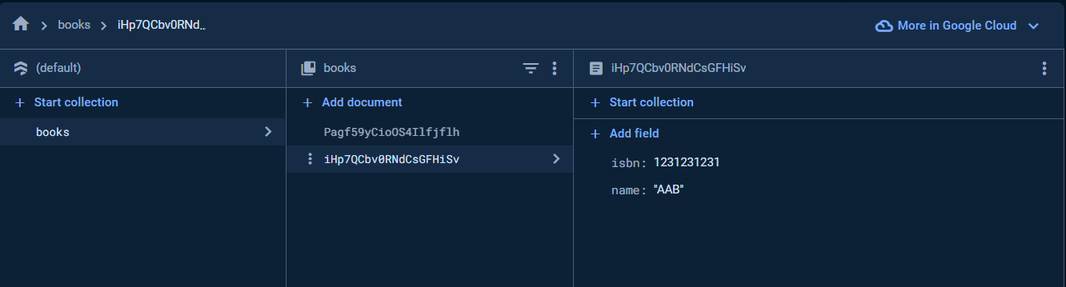

**EFOLIO TASK 8.2**

**Screenshot set 1:**

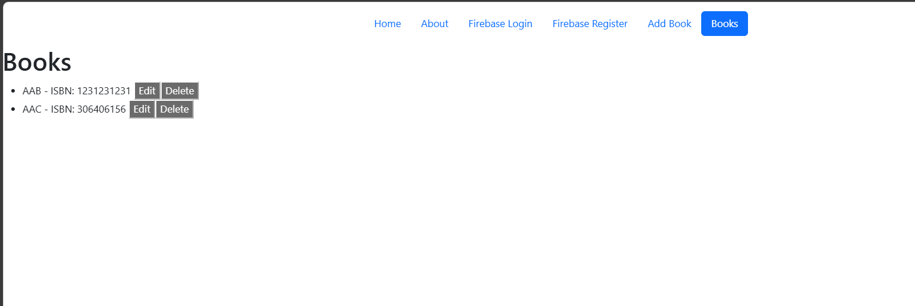

BookList.vue:

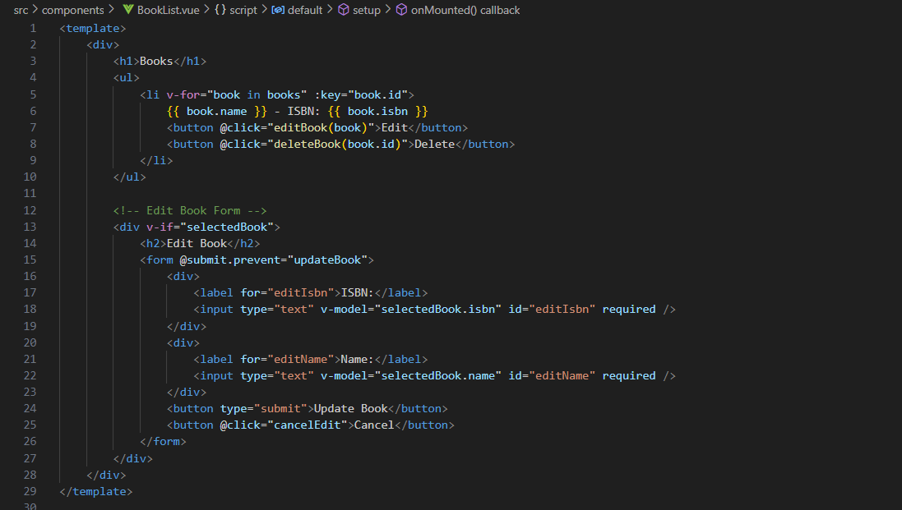 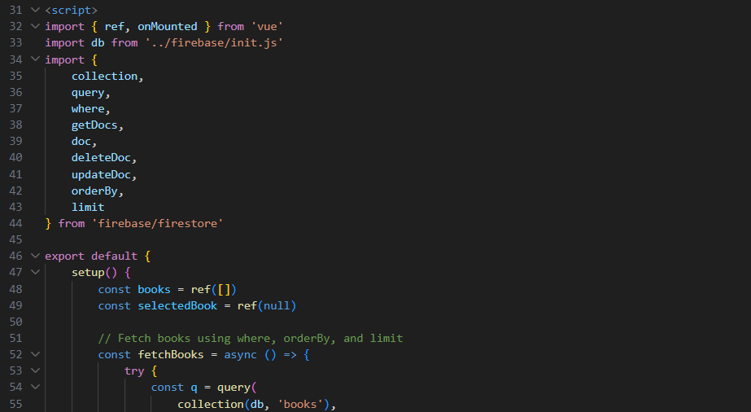 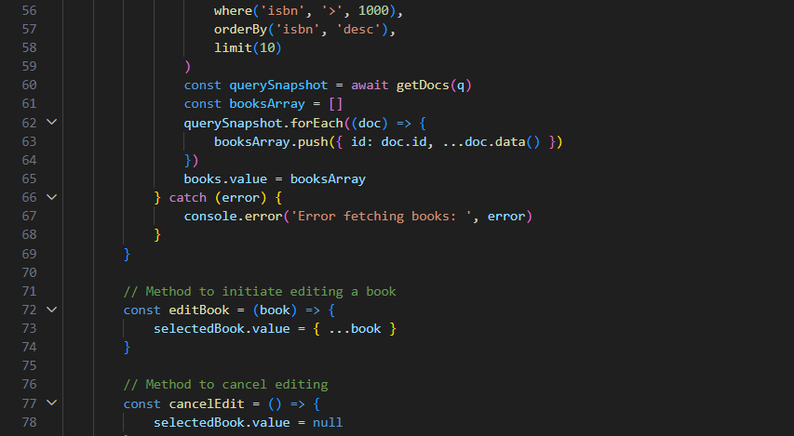 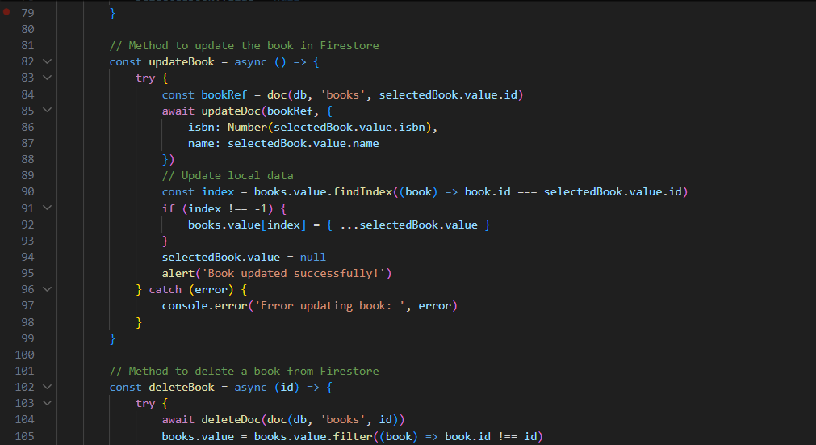 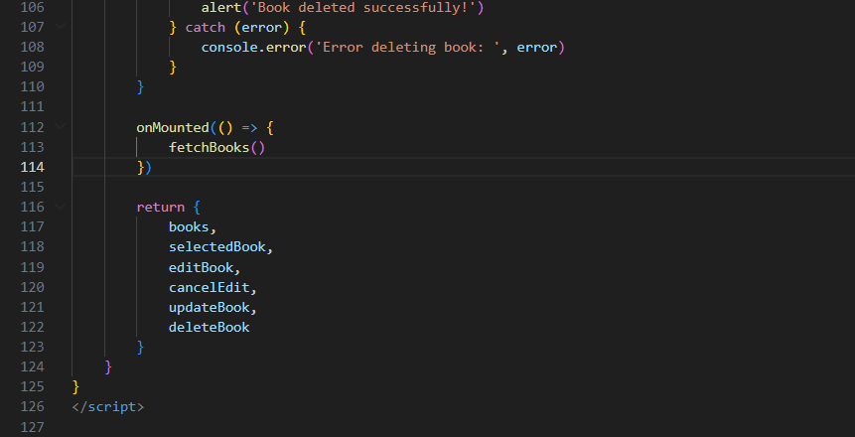

**Screenshot set 2:**

When the condition is set to ISBN greater than 100:

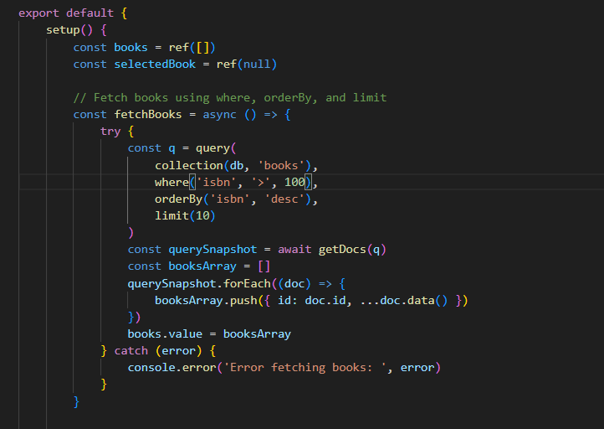

The web page is displayed as follows:

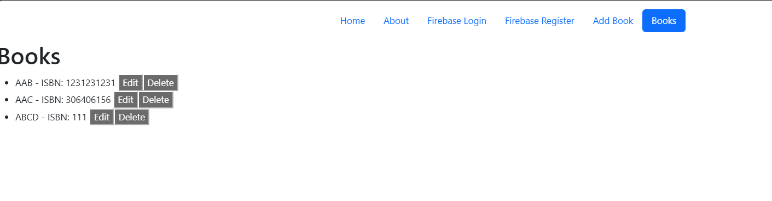

When the condition is set to ISBN greater than 1000:

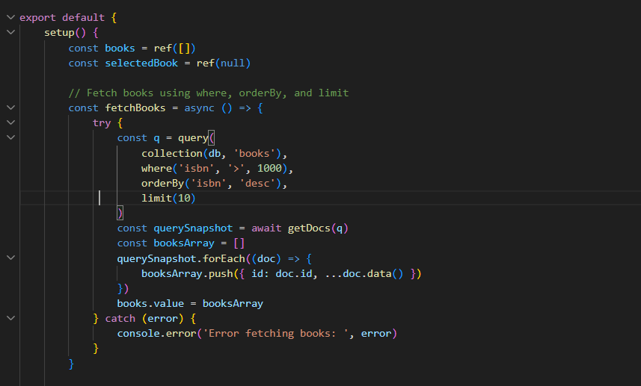

The web page is displayed as follows:

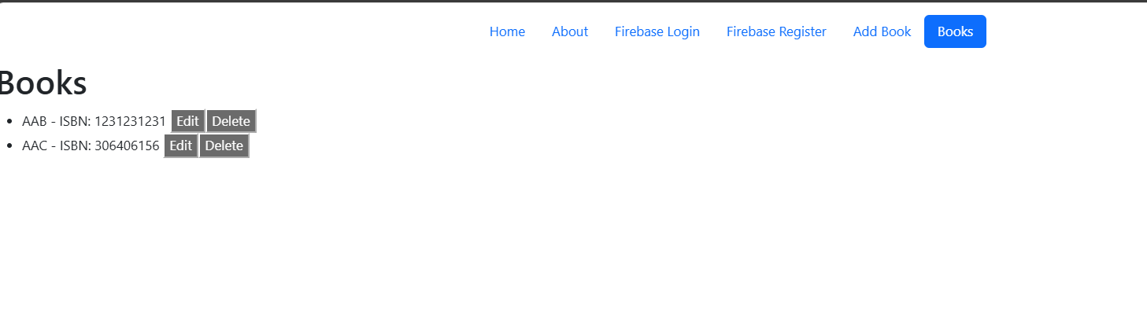

This demonstrates that I can use where, orderby, and limit to retrieve data from the database.

GIT COMMIT:

